# Purpose of this document

Instructions on how to export record and item buckets from Evergreen and import into the Rotations Manager.

# Step 1 – Export record bucket

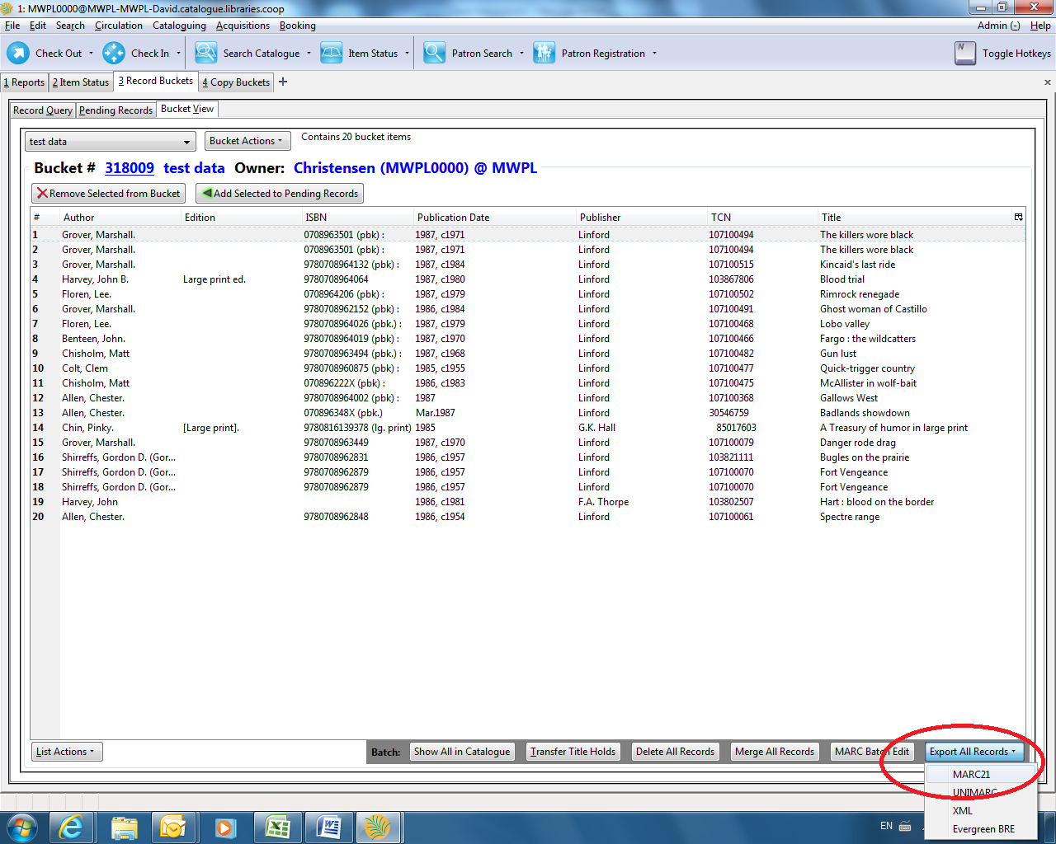

Go into your record bucket.

In the lower right corner of the screen, there’s a drop-down menu to “Export all records”; choose “MARC 21” format.

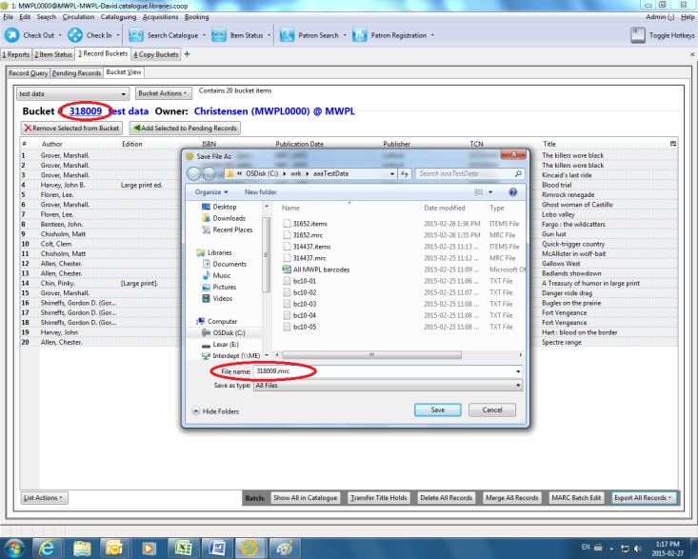

This will pop up a “Save as” window.

Find the folder you want to save into (desktop is ok).

Use the record bucket # as the file name, but add a “.mrc” on the end. This is how the uploader will know that this is a file of MARC records.

# Step 2 – Export copy/item bucket

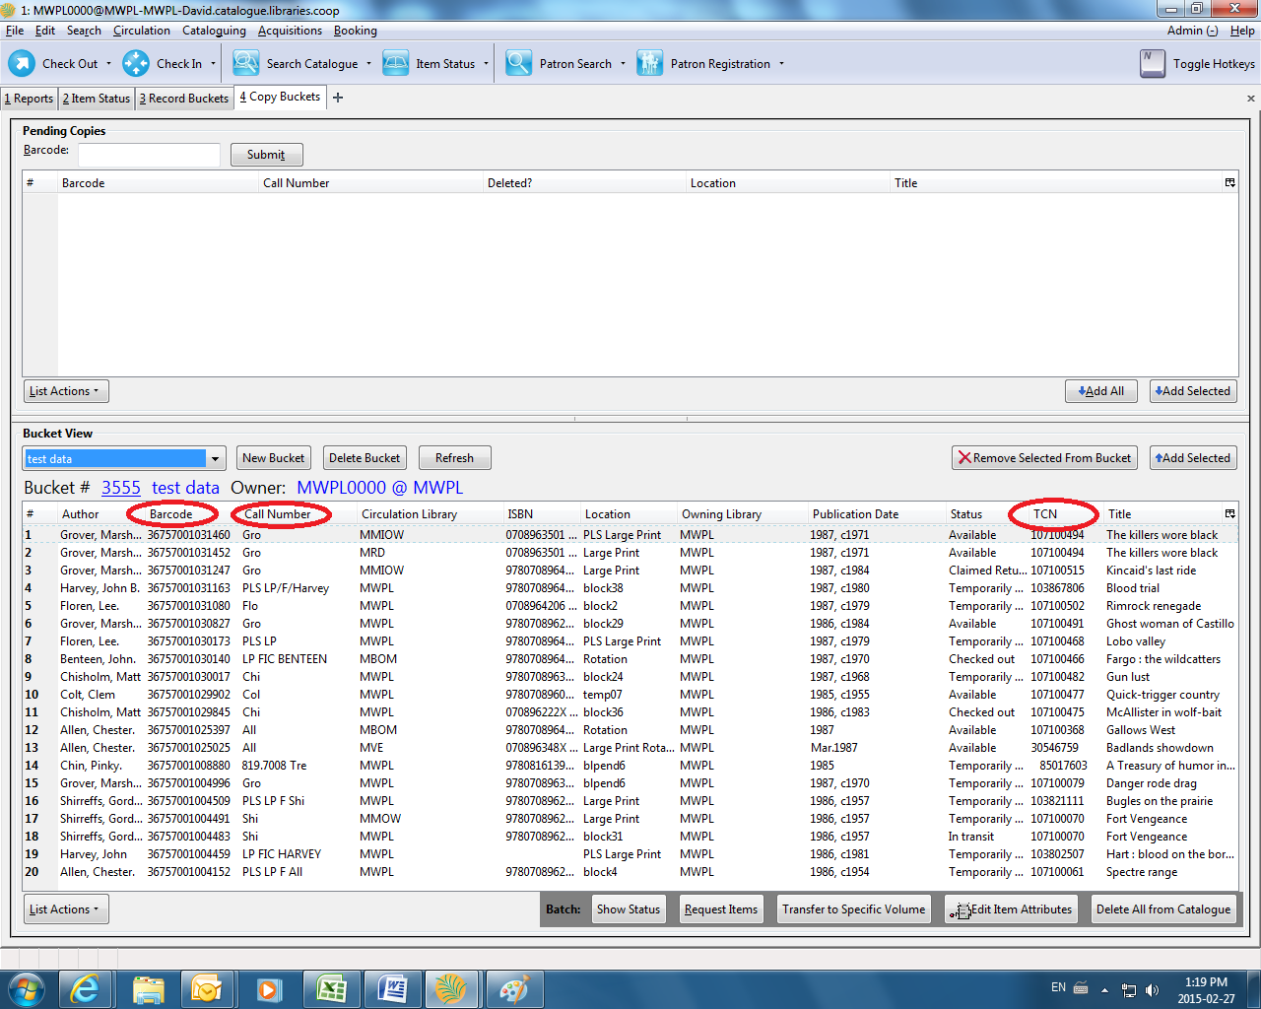

Go into your copy bucket.

You want to make sure that (in addition to title, author, etc) the table displays the barcode, call number, and TCN fields.

(The TCN field is what the uploader uses to link the copy information to the MARC record.)

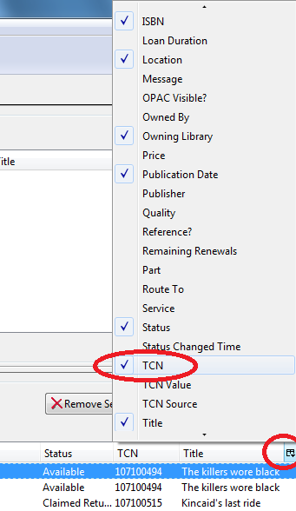

You can add these fields using the “cherry-picker” widget at the upper right corner of the items list. It will pop up a menu of fields you can add/remove.

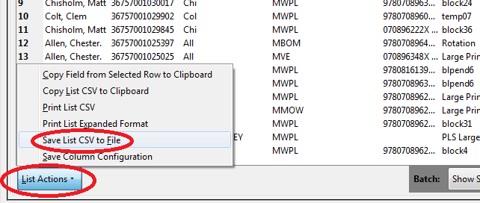Once the fields are displayed, click on the “List actions” button in the lower left corner.

(You can click “Save Columns Configuration” to never have to do the cherry-picker bit again.)

Click “Save list CSV to file”.

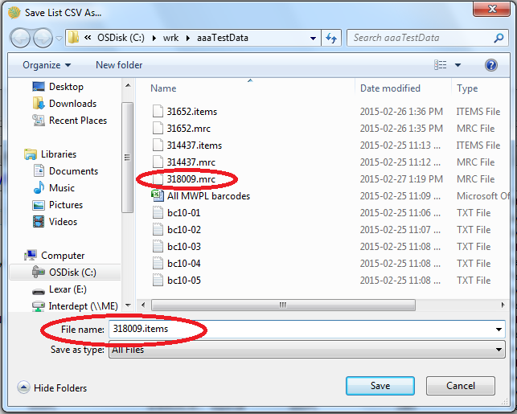This will pop up a “Save as” window.

Find the folder you want to save into (desktop is ok).

Use the same name (i.e. the **record** bucket number, just like the .mrc file), but use “.items” as the extension.

Click “Save”

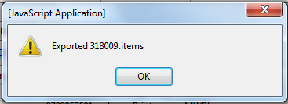You’ll get a little info box saying the file has been exported.

Click “Ok”

# Step 3 – Upload and process

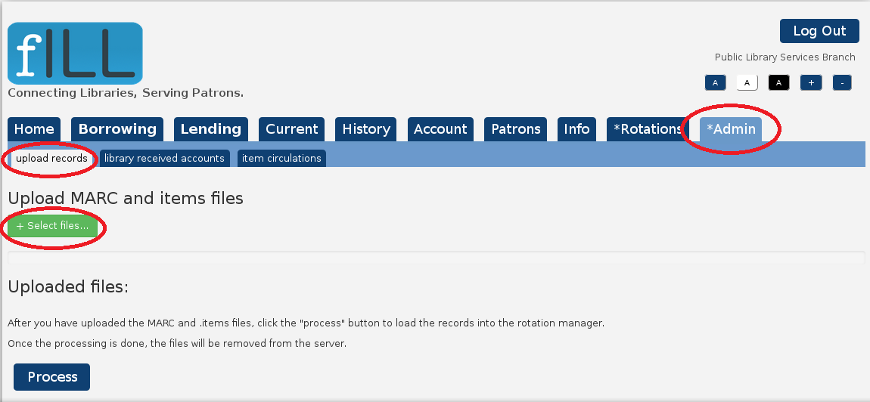

Get into fILL, and select “Admin” > “Upload records” from the menu.

Under the “Upload MARC and items files” heading, click the “Select files” button.

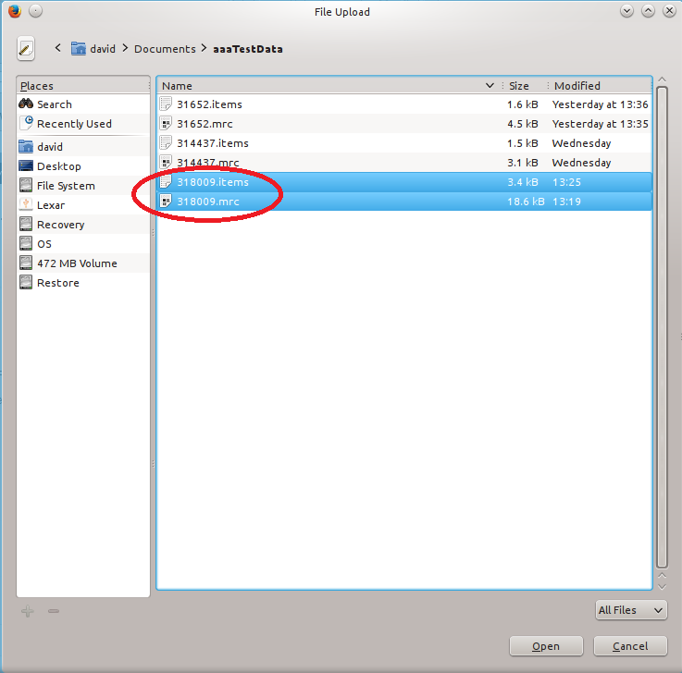

A file selection window will pop up. (it may not look exactly like this – this is using Firefox, you’ll be using Internet Explorer).

Go to the folder where you saved the .mrc and .items files to.

Select both the .mrc and .items files by clicking on one of them, and then holding down the CTRL key and clicking on the other. Click the “Open” button.

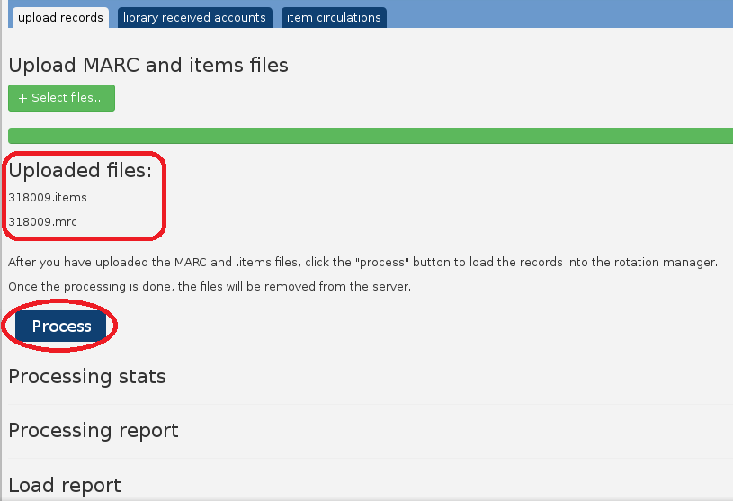A green progress bar will show the upload progress – it’s very quick.

When it’s finished, the section under “Uploaded files” will show the two files you’ve just uploaded.

Click the blue “Process” button.

This will start the process of adding the items to the MARC records, and then automatically load the records into the Rotation Manager.

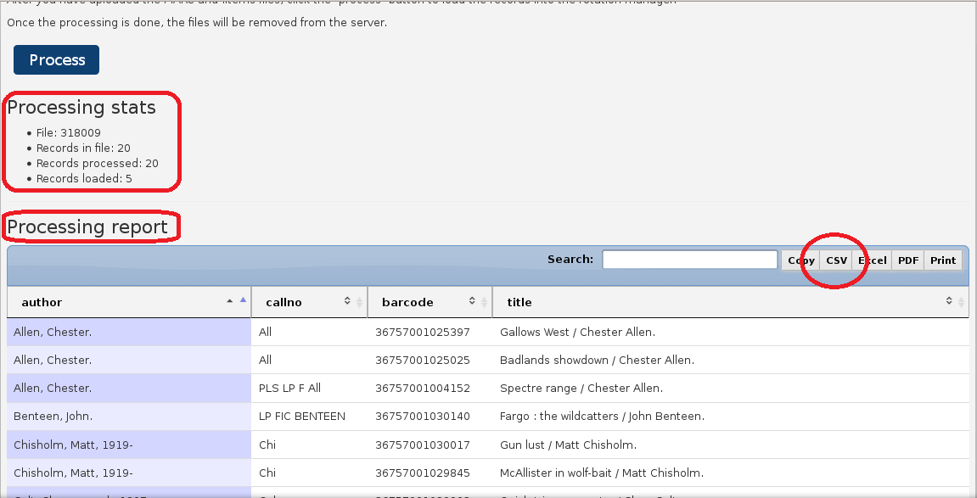When it’s finished, you’ll see information in the three sections:

“Processing stats” - the file name, the number of records in the file, the number of records processed, and the number of records loaded.

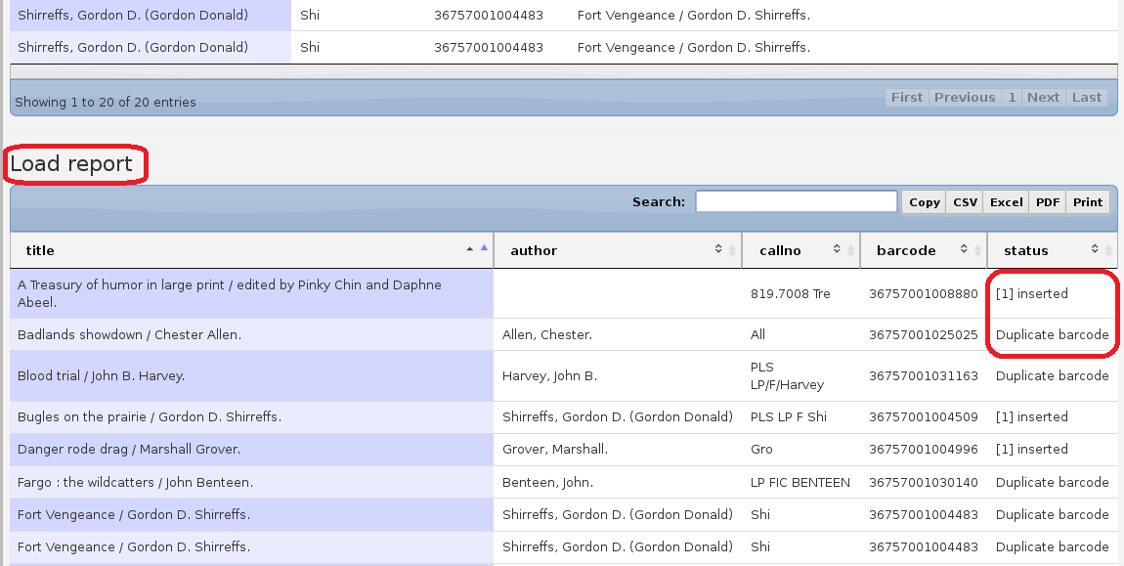“Processing report” – this replaces the old ATC list. You can click on the “CSV” button at the top of the table to export the list (in a format that can be loaded into Microsoft Excel).

Scroll down to “Load report” – this will give you the status of each record from the file. It will indicate whether that record was loaded, or if it was skipped (e.g. “duplicate barcode” – the record already exists in the Rotation Manager).

And you’re done!